Apply for TSDS Access

Users that will be submitting, reviewing, or completing a PEIMS or Core Collection will need to have access to Texas Student Data System (TSDS) to access those collections and/or the Data Management Center (DMC).

- Log into TEAL.
- Click on My Application Accounts.
- Click on Request New Account.

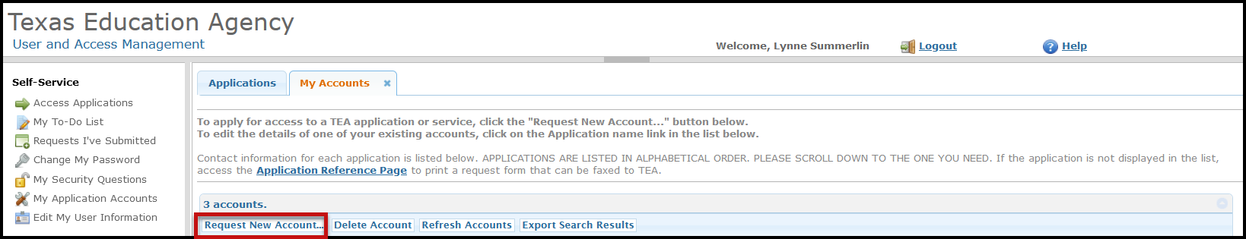

- In the pop-up window, select TSDSPortal - Texas Student Data System Portal.

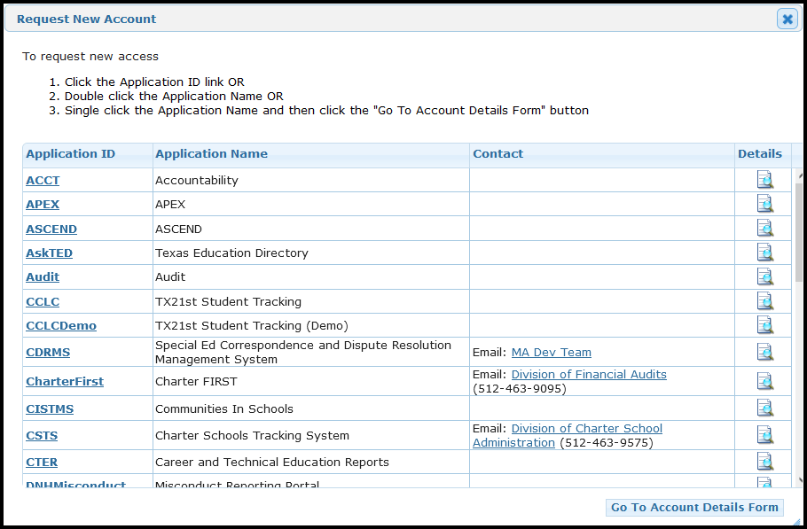

- Click Add Access.
- Click Done.
- Click *Save Changes*. It is important that you click Save Changes before you exit the screen.

